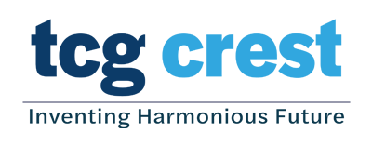
Research Institute for Sustainable Energy (RISE)
Research Institute for Sustainable Energy (RISE) of TCG Centres for Research and Education in Science and Technology (TCG CREST) invites applications from prospective Ph.D. candidates interested in Energy Science. The topics of research are in the areas of Solid State Battery, Lithium and Sodium Ion Batteries, Electro-deposition of Metals, and Electro-catalysis/Photocatalysis.
Students in their final semester pursuing M.Sc/B.Tech/M.Tech/BS-MS Degree in Physics, Chemistry, Material Science & Engineering, Chemical Engineering, Nanotechnology and other such related areas, who have qualified in NET, GATE, DST Inspire Fellowship may apply. For short-listing, candidates who meet the eligibility criteria are encouraged to email their Curriculum Vitae before 30 June, 2022 to: rise@tcgcrest.org. The shortlisted candidates will have to appear for a selection interview. If deemed necessary, prospective candidates may also have to write a qualifying examination.

Application Deadline: June 30, 2022

Junior Research Fellowship
Rs. 40,000/- per month
(inclusive of HRA)

An appropriate contingency amount will be provided for attending National/International conferences and other such expenses
Please visit https://www.tcgcrest.org/institutes/rise/ for more details
Interested to Pursue a Doctoral Degree in the Field of Clean and Renewable Energy?
www.tcgcrest.org
First Floor, Tower 1, Bengal Eco Intelligent Park, Block EM, Plot No 3, Sector V, Salt Lake, Kolkata 700091, INDIA
For specific queries, please call Dr. Abhik Banerjee at +917365834846

